Chapter 17, Problem 60.

Obtain the complex Fourier coefficients of the signal in Fig. 17.62.

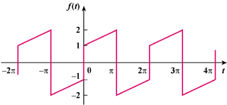

Figure 17.62
For Prob. 17.60.

